Make sure you have install python.

- pip install ipython
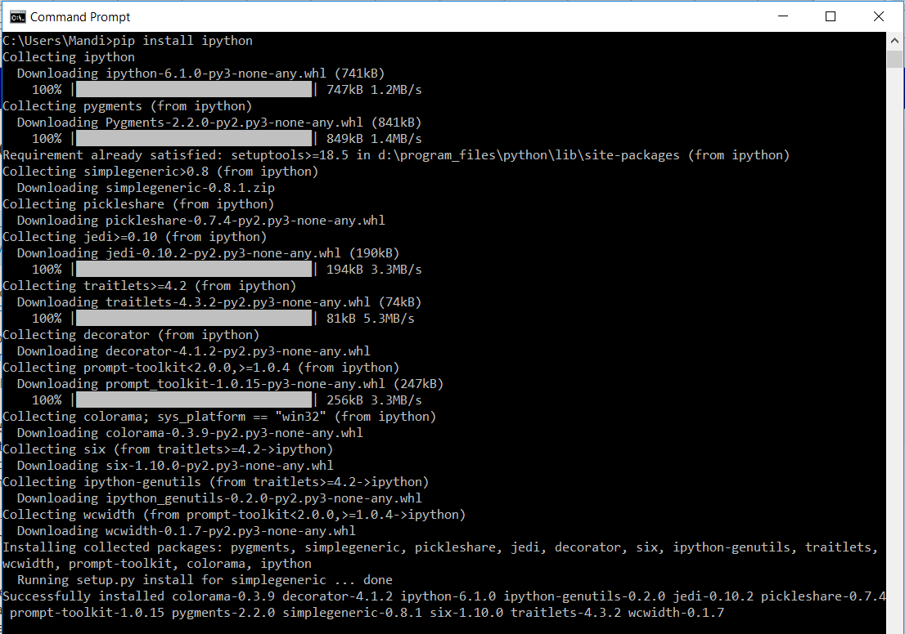

- pip install notebook
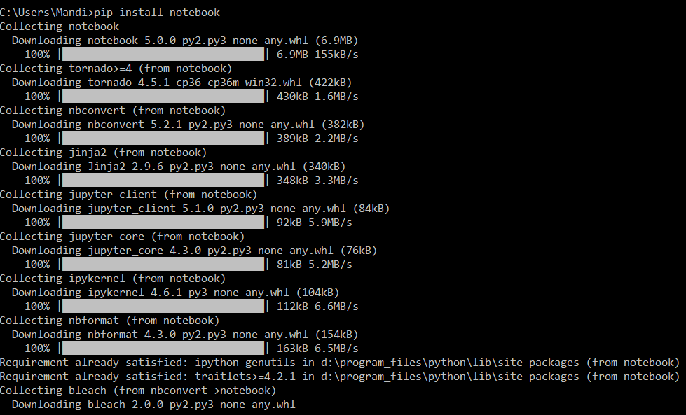

- Specify your working directory, then enter the command “jupyter notebook”

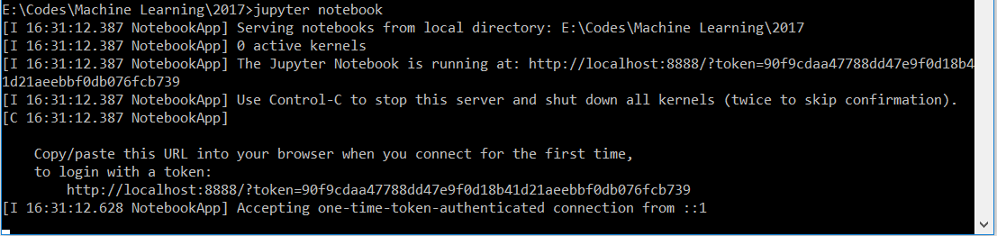

It will be running automatically in web browser:
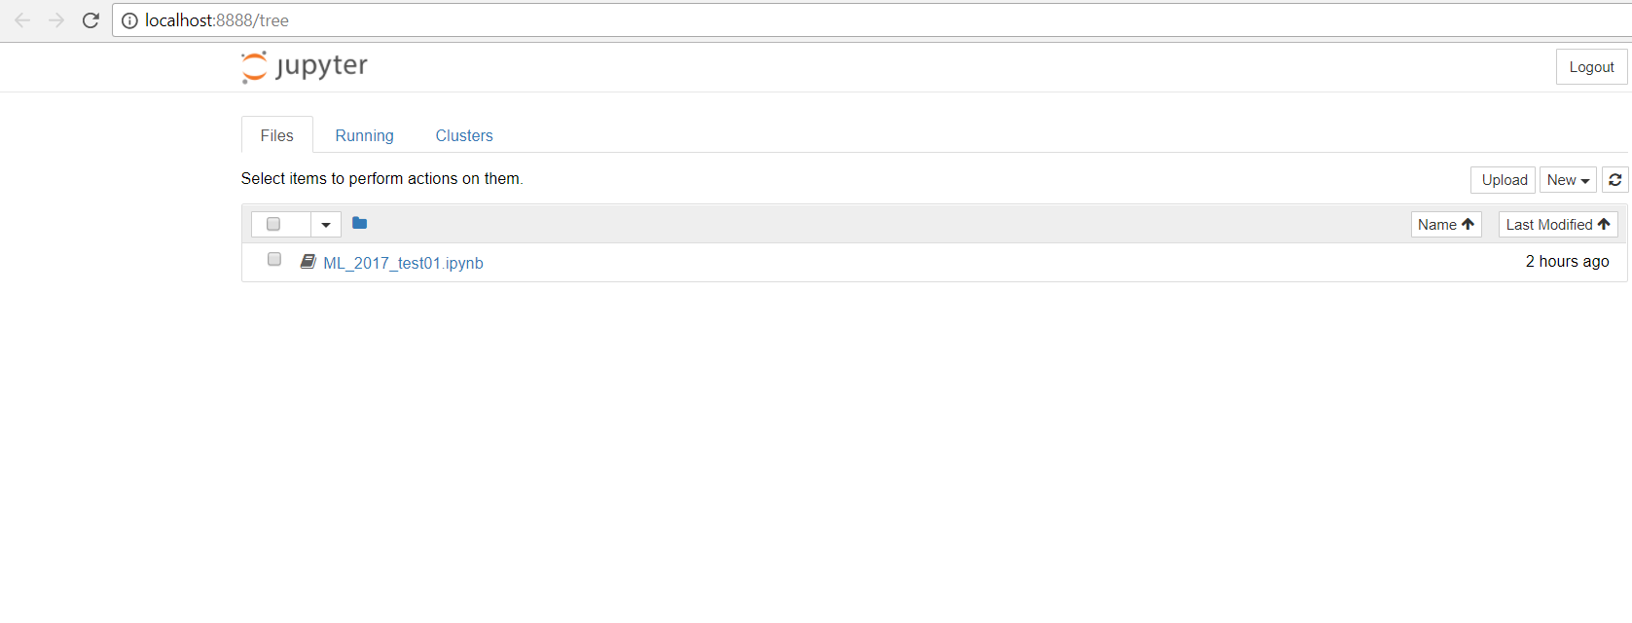

- Click on “New” button, it will create a new .ipynb file.
Edit your codes in the web browser:
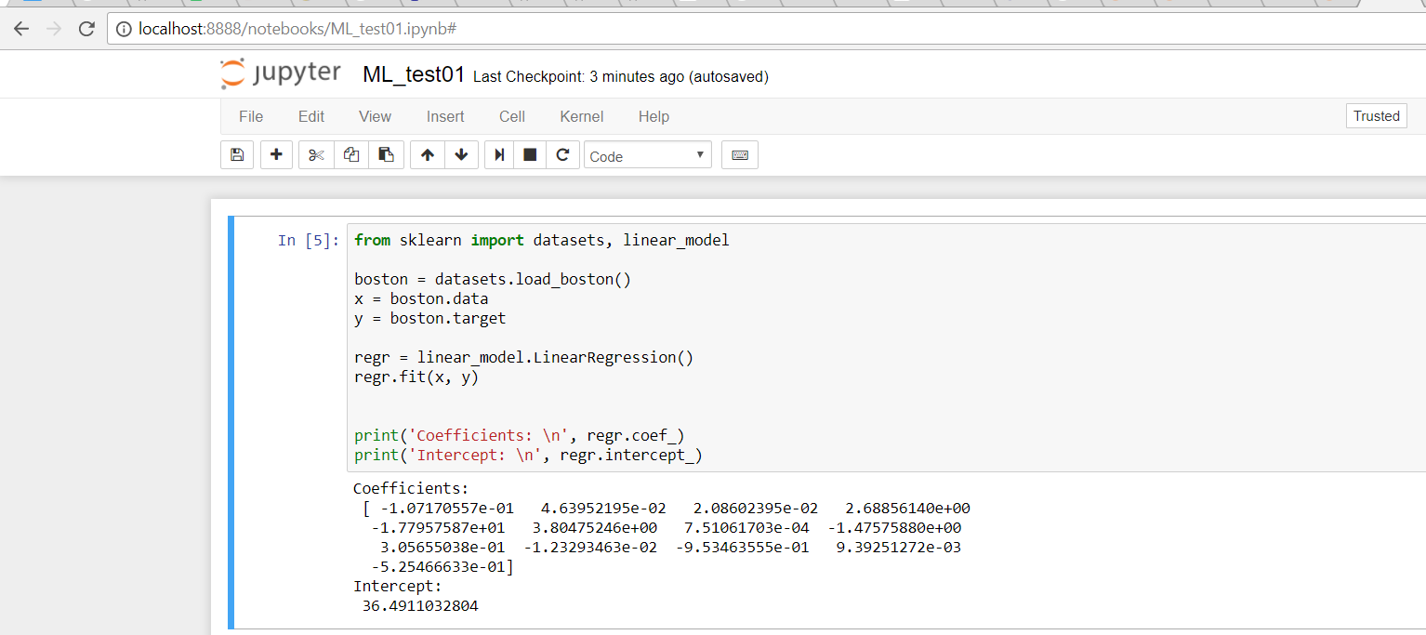

- The .ipynb file is in Json format.
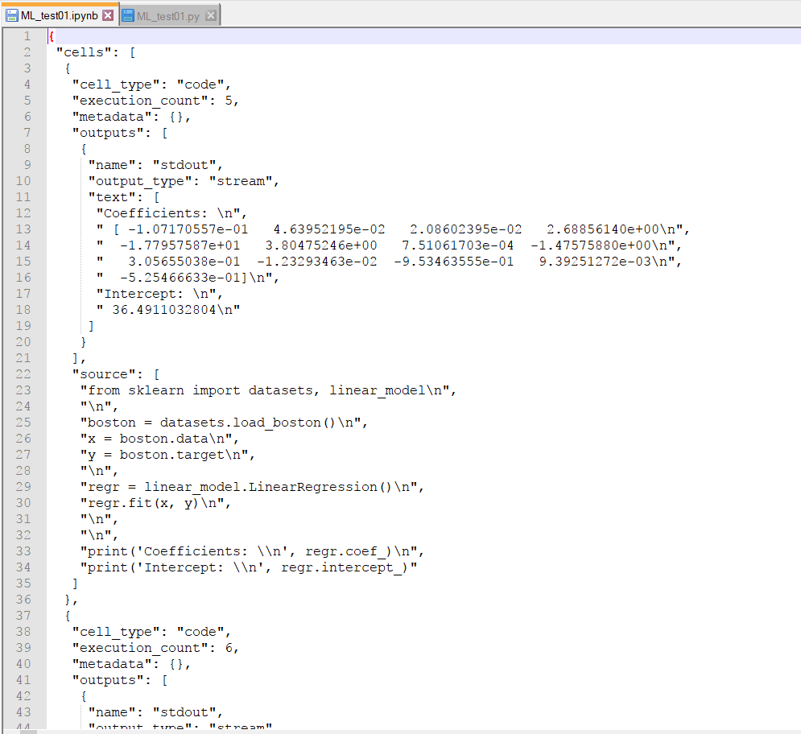

It can be downloaded as .py file or other formats.
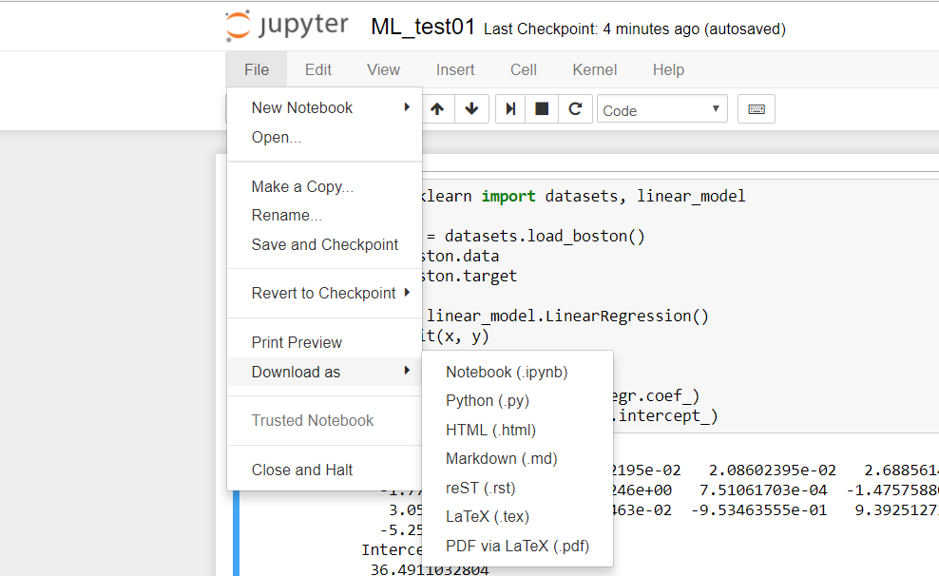

- You can also create your .ipynb file in IDE.

